MEMORANDUM

TO: Honorable Mayor and Town Council Members

FROM: Matt LeCerf, Town Manager

DATE: February 06, 2023

CC: Town Staff
Local Media

SUBJECT: Town Manager’s Report

Upcoming Town Council Meetings & Work Sessions – If there are topics that the Council would like staff to schedule for discussion, please let me know. The following topics are recommended for Council discussion (all meetings will be held in the Town Council Chambers unless otherwise indicated):

- 02/06/2023 – Regular Council Meeting
- 02/22/2023 – Regular Council Meeting

Administration, Finance, Planning, & Human Resources
- Land Use Code – A Public Working Draft has been posted to the Town’s website and sent to Council, the Steering Committee, and the Planning & Zoning Commission for review of the solutions presented to implement the ideas and concepts within the Johnstown Area Comprehensive Plan. A Council Work Session was held on January 30. Once a final draft is prepared to incorporate revisions, public hearings will be scheduled.
- Strategic Planning – Work is continuing on the development of the strategic plan. The next internal meeting for staff has been scheduled for the middle of February.
- Community Survey – The community survey closed on January 3, 2023. The Town received a total of 427 responses, with 240 of those being paper responses and 187 being web responses. We expect to receive the final results of the survey from Polco in the next couple of weeks.
- Water Conservation – Staff attended a meeting with Northern Colorado Water to discuss the potential for collaborative messaging on water conservation with NCW and other municipalities moving forward.
- Climate Smart Future Ready – Staff attended a Built Environment Work Session organized by Larimer County to participate in this community-wide planning effort.
- Planning & Zoning Commission – The Planning and Zoning Commission (PZC) held hearings on January 25, with a February 15 meeting planned for next month. Jim Hatfield was sworn in as an acting commissioner. PZC is also reviewing the draft Land Use & Development codes and providing feedback to Town Staff.
- Municipal Court – 111 cases were processed in Municipal Court for January of 2023. The RFP for a relief judge closed and staff will begin processing responses received.
- Business Licenses- A second notice to businesses who have not renewed for a 2023 business license has been sent out.
- Liquor Licensing – TA Operating LLC dba Petro Shopping Centers has submitted a Fermented Malt Beverage Off-premises liquor license renewal; Mini Mart Inc dba Loaf ‘N Jug #750012 has also submitted a renewal request for a Fermented Malt Beverage Off-premises license. BD of Colorado LLC dba Bad Daddy’s Burger Bar has submitted a Hotel & Restaurant Liquor License renewal. Notice has been sent to all Fermented Malt Beverage Off-premises license holders of the upcoming license class change to Fermented Malt Beverage and Wine Retailer Liquor License. This change will automatically happen on March 1, 2023 as a result of the November 8, 2022 election amendment to Articles 3 and 4 of Title 44 in the Colorado Revised Statues, and no action is needed from the license holders or Council. Hayes Market has submitted an application for a modification of premises in preparation of that license change.
- Hiring – The Town is currently searching for a Planner I, Planner II, Building Permit Technician, Water Treatment Superintendent, Wastewater Treatment Superintendent, and Police Officers.
- 508 Compliance and Website Accessibility – The Comms Office has begun working on 508 website compliance and Town digital environment compliance. Having a website that is 508 compliant and that follows WCAG Guidelines 2.0 is important for the Town of Johnstown because it provides more equal access to information and promotes transparency. 508 compliance for the Town’s digital environments is an ongoing commitment to information transparency and the below graphic will express the Town’s ongoing effort towards compliance and, eventually, towards maintenance of an accessible digital environment.

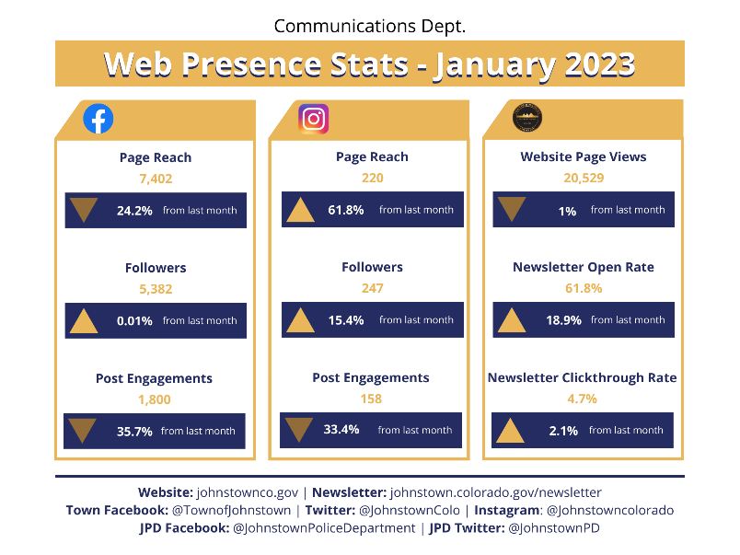
Town Communication Tools – As a reminder, the Town has a number of communications tools in its toolbox including social media, a newsletter, email communications, and website. Each tool is important for delivering Town information to residents, businesses, and visitors in a timely and impactful manner. Residents are always encouraged to bookmark the Town’s website as this space hosts the largest amount of information online about the Town. Residents are also encouraged to sign up for the Town’s various informational email topics and check their mailbox monthly for the Town newsletter and other information.
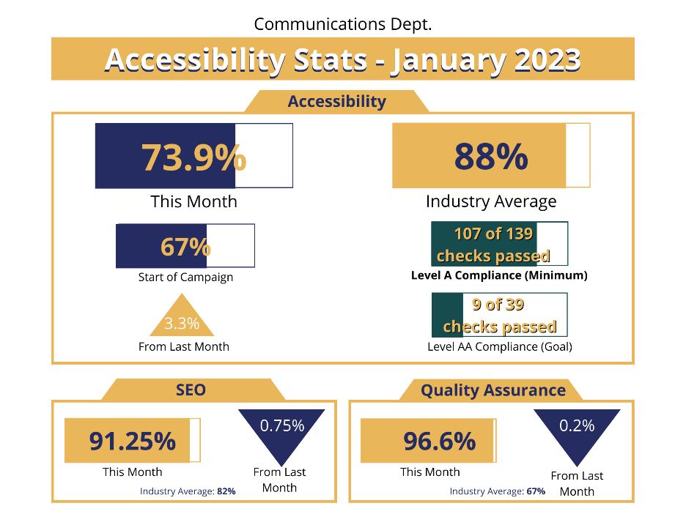
Police Department
Training:
- Internet Investigations Training – Detective Grounds, Detective Sergeant Slocum, Christy Adair, and Commander Oglesby attended a two day course called “The Internet-Investigations and Intelligence,” put on by the National Domestic Communications Assistance Center and the FBI.
- Traffic Accident Investigations– Officer Dion Wild attended the weeklong Level 1 accident investigator school.
- DUI Intoxilizer training – Officer Soricelli attended the I-9000 EBAT Operator certification course. He is now certified to use the I-9000 Intoxilizer for evidentiary breath tests.

Community Policing, Outreach & Miscellaneous Items:
- Life Saving Response – Officer Hewell was dispatched to a fentanyl overdose where the victim was unconscious and not breathing. Officer Hewell performed CPR until a pulse was regained, saving the victims life! Officer Hewell is a new officer two months out of the police academy.

Public Works
- Crews completed 32 work orders this review period consisting of filling potholes, road sign repair, remove holiday decorations, snow and ice removal, and a variety of other street related work.

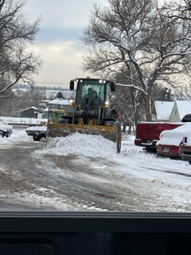

- Charlotte Street Improvements – Work continues on the north side of the roadway installing sidewalk and driveways. The Contractor is waiting for Xcel gas to hire a contractor for installation of the gas line. Below is the two week look ahead:
January 23 - February 4, 2023 (All work is on north side of roadway):
    - Excavate for sidewalk/ADA ramps
    - Install storm pipe
    - Import Class 5 Road Base for sidewalk
    - Form and prep sidewalks
    - Form and prep storm inlets
    - Pour sidewalk
    - Place storm manholes

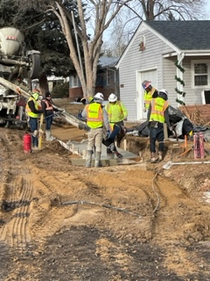
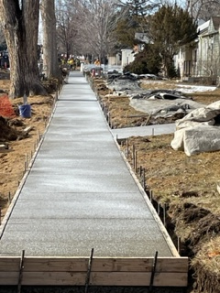

- Traffic Signal Design for Carlson Blvd and State Highway 60 – Town Staff has bid the project on January 11, 2023. The bid opening is scheduled for 2:00 PM on February 2 at Town Hall. The traffic signal poles are on order.
- State Highway Feasibility Study – Town Staff met with CDOT to discuss the report on January 20. CDOT had a few comments and suggestions and will be issuing final comments to address in the report before approval. The main suggestion was to add that a future transit would be completed to see if SH 60 needed to address future transit needs. It was agreed that that study would not be needed before Johnstown reached a population of at least 50,000.
- Little Thompson River Trail- The project was delayed due to harsh weather and will commence the week of January 30.
- Letford Elementary School Site- (no change) Hazardous removal inside the buildings is complete and staff met with the contractor on January 3 to go over the building demolition plan and schedule.
- Colorado Boulevard Design – Design of ultimate improvements to Colorado Blvd by Purvis and Corbet Glen continues to progress. Water and sewer design issues have been worked out with the Utilities Department.

Utilities
- Treatment
  - WTP:
    - Average Daily Flows: 1.22 MGD
    - Took the north ground storage tank at the plant offline and had it inspected. Staff will utilize the report to develop a plan to repair the tank.
    - Improving coordination with C&D crews on water system flushing and repairs that require the WTP to be notified.
  - Low Point WWTP:
    - Parts to repair the solids handling equipment is scheduled to arrive next week.
    - Staff called in a Contractor to liquid haul the basins weekly to maintain operations until repairs are complete on the solids handling equipment.
  - Central WWTP:
    - One blower repaired and parts ordered for the two blowers on Pond 2
    - Plastic media for treatment arrived to replenish the MBBR basins
- Utilities Sewer Collection & Water Distribution
  - Locates: 239 curb stops & 5800 ft of water and sewer main lines
  - Inspections: 29
  - Meters: 14 replacements & 33 new installs
  - Repaired leaking valve at the PRV in Rolling Hills
  - Assisted with main line location research at Main Line research using the new vacuum trailer out at Water Treatment Plant and Front Range Fire Rescue
  - Broken 8” clay sewer repair on Parish Ct.
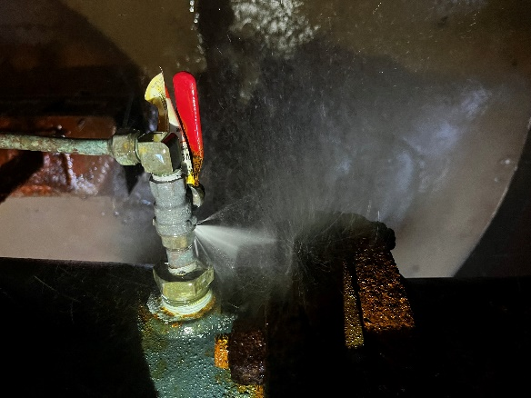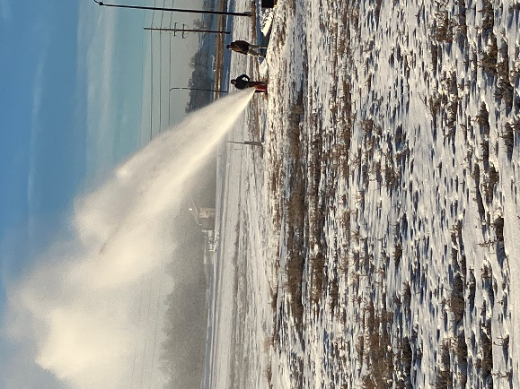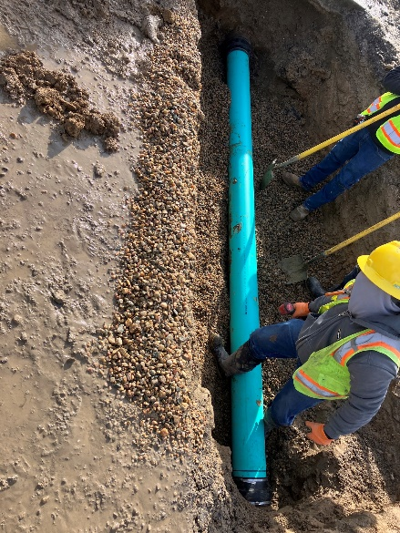
- GIS
  - Created Lead & Copper layer based on year-built data to identify unknown service materials for Revised Lead and Copper Rule. Approximately 700 properties that require identification.
  - Assisted with HUTF mapping for Public Works.
  - Wrapping up mapping using LETA aerial imagery in Larimer County to map sewer and stormwater manholes.
  - Checking into new Weld County aerial imagery to map Weld County sewer and stormwater manholes.
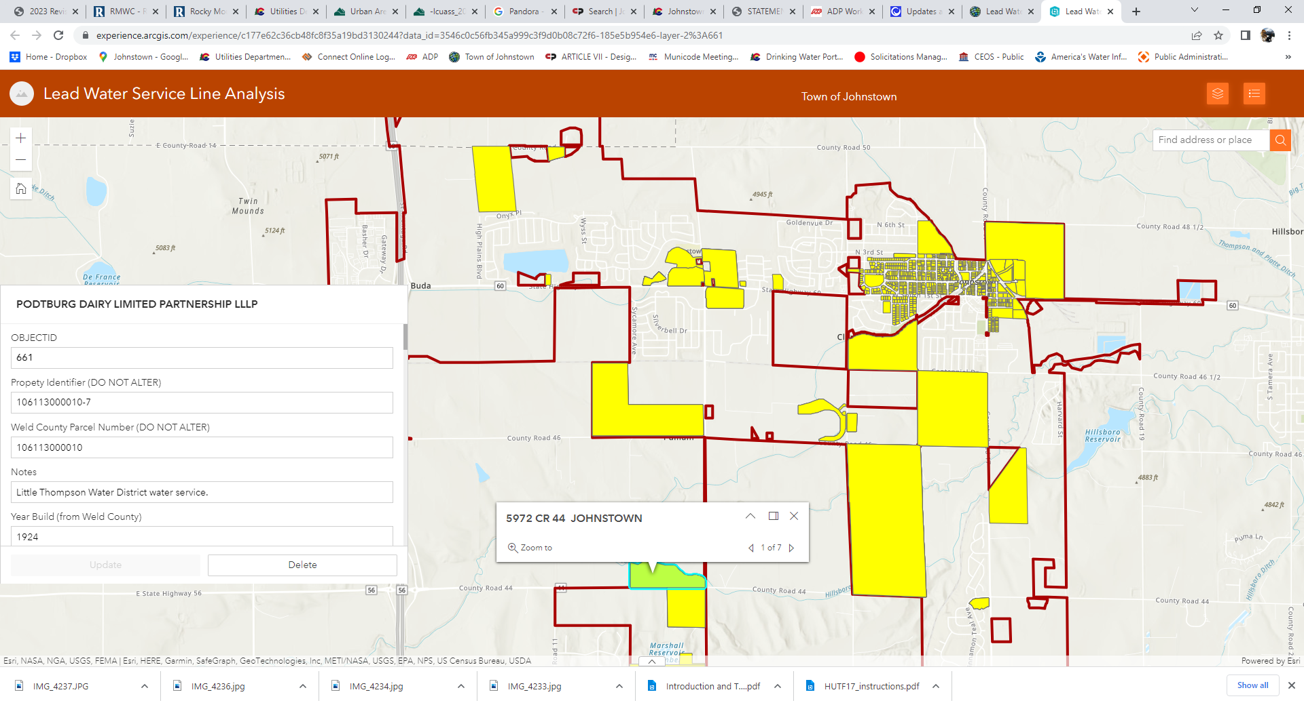
- Capital Projects
  - Raw Water Transmission – Town Staff and the design engineer held a workshop to discuss alignment options. The design engineer will continue to work with Town Staff to set the final alignment from Lone Tree to the Water Treatment Plant. The Town is also working with the Hillsborough Ditch Company on the location of the new pump station.
  - South Water Tank – The tank contractor is continuing to work on the interior piping, electrical, and civil site work. The painting crews will likely need to come back in the spring to finish. Town staff is coordinating with United Power to install the electrical service for the Tank.
  - South Water Tank Distribution Pipeline – The contractor is working on installing mainline along WCR 13. The Hillsborough bores are complete. The contractor has been delayed due to the weather in January, but we will continue to work together as the project is nearing completion.
  - Water Treatment Plant Expansion – Town Staff, the design engineer, and the owner’s representative have met and reviewed the membrane proposals. Town Staff will start contract negotiations with the selected firm and intend to have a Professional Services agreement in the coming weeks. The selected CMAR firm is planned to be on board in early February.
  - Central Interceptor Phase 2 – Town Staff intends to issue notice of substantial completion in early February. The contractor will complete demolishing the Clearview lift station and force main as weather permits.
  - North Interceptor – The contractor has completed pouring the floor slab for the lift station wet well. In addition, the contractor will begin installing main line from the central wastewater treatment plant to the west. Town Staff continues to coordinate critical easements and crossing agreement with the Hillsborough Ditch Company and property owners. The railroad crossing has been approved.
  - 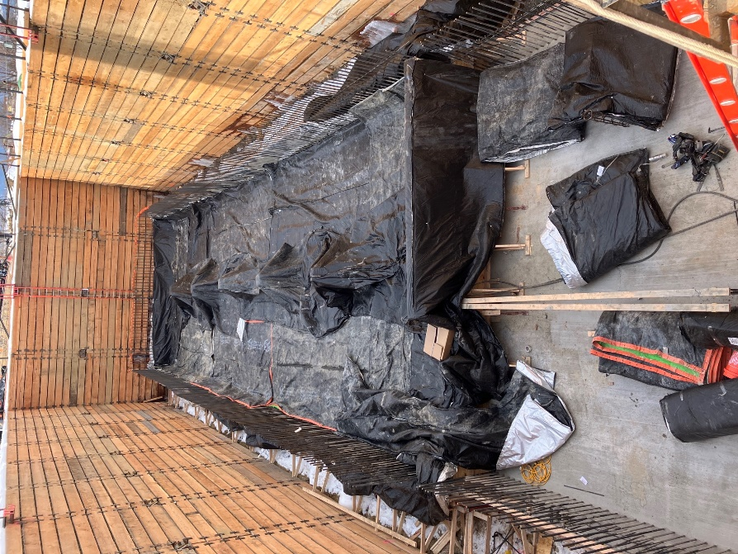
  - Low Point Sewer Expansion – The contractor continues installing equipment in the Membrane Bioreactor (MBR) building as it arrives on site as well as coating the interior walls. The new headworks building is progressing right behind the MBR building as trades complete their work the MBR building.
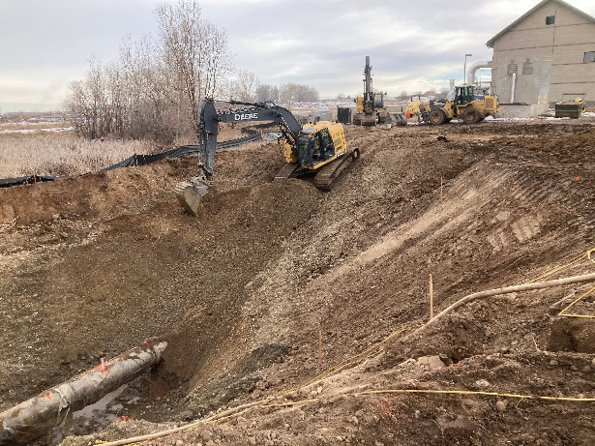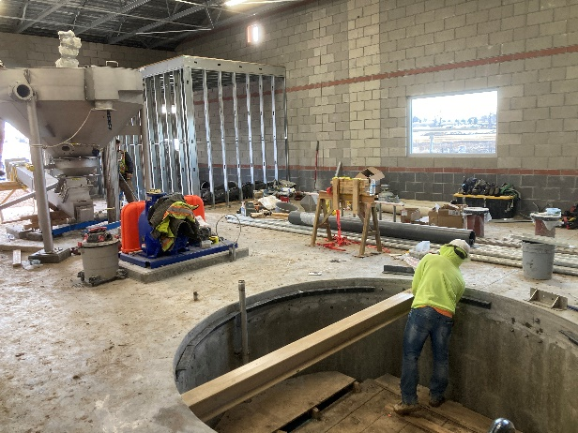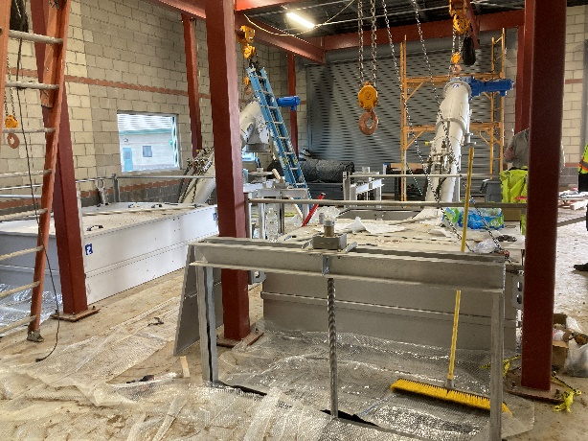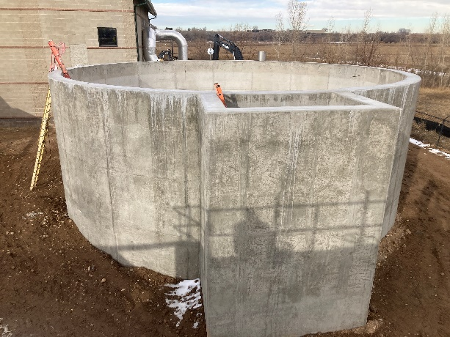
  - Central Plant Design – The Design Engineer has submitted the 90% construction plans. Town Staff, the design engineer and the CMAR will work on value engineering as the design progresses and look at developing the Final GMP based on the 90% plans. Town Staff has obtained all adjacent easement for the construction of a new outfall pipe.
  - State Highway 60 Waterline – The contract for the design services has been awarded to JUB Engineers. Over the next six months town staff will work with the design engineer on final alignment and obtaining all necessary easements and agreements.

