MEMORANDUM

TO: Honorable Mayor and Town Council Members

FROM: Matt LeCerf, Town Manager

DATE: May 01, 2023

CC: Town Staff
Local Media

SUBJECT: Town Manager’s Report

Upcoming Town Council Meetings & Work Sessions – If there are topics that the Council would like Staff to schedule for discussion, please let me know. The following topics are recommended for Council discussion (all meetings will be held in the Town Council Chambers unless otherwise indicated):

- 05/01/2023 – Regular Council Meeting
- 05/15/2023– Regular Council Meeting

Administration, Finance, Planning, & Human Resources
- Town Clerk – A special event application has been received for BBQ Days for June 3, 2023.
- Municipal Court – Staff will begin sending text reminders to defendants prior to their court date in an effort to encourage attendance. 104 cases were processed in Municipal Court in April 2023.
- Business Licensing – Staff will start moving forward with BluDot, the current software company utilized by the Economic Development Department, for an online portal for new and renewing business licenses. Communication to local businesses will be sent when the portal is ready to go live.
- Hiring – The Town is currently searching for a Public Works Director, Planner I, Planner II, Utility Operator, and more Police Officers. We recently promoted a Public Works Streets Crew Leader from internal staff.
- Training – Staff from Public Works and Utilities completed training in several safety and workplace topics through CIRSA.
- Franchise Agreements – The Town has been working on a new franchise agreement with Comcast. The draft agreement will be presented to Council for consideration on May 1.
- Aquatics Center Feasibility Study – The first meeting for the committee is scheduled for May 1. The meeting will allow the committee members to introduce themselves, review the purpose and expected deliverables, and nominate a chairperson. The project kickoff meeting with the consultant has been scheduled for May 30.
- Strategic Planning – In April, the department heads finished putting together some broad goals for each pillar. The next step in the process is meeting with and collecting feedback from all employees to ensure that nothing has been overlooked.
- Regional Job Fair – The Town of Johnstown, in partnership with several communities and partners, is hosting a job fair on May 16 from 4-7pm at Aims Community College, Windsor Campus. The following Johnstown businesses will be participating:
  - Scheel’s
  - Five River Cattle
  - Nadora Healthcare
  - Wing Shack
  - YMCA
  - Exodus Moving & Storage
  - Sun Mountain Custom Doors
- Business of the Month – Connected Chiropractic was April’s Business of the Month. They are located within the downtown corridor at 32 S. Rutherford Avenue.
- Biz Walk – The Town Manager, Deputy Manager, and Economic Development Manager continue to schedule monthly biz walks with our local Johnstown businesses. In April, staff met with FedEx Distribution Center.
- Downtown Johnstown Branding & Wayfinding Project – Town Staff presented to Town Council on Monday April 3 the final downtown brand/logo. Staff is currently in Phase 3 of the project which includes designing the wayfinding signage for the downtown that will reflect the adopted brand/logo and developing a Town wide master plan for wayfinding signage.
- ICSC – Town Staff and Council will be attending ICSC from May 21-23. ICSC is the largest retail convention that provides deal-making opportunities between retailers, developers, real estate firms, and municipalities. Town Staff is currently prepping for the mission trip and will provide those attending an itinerary closer to the date.
- 508 Compliance and Website Accessibility – The Communications Office continues to work on 508 website compliance and Town digital environment compliance. Having a website that is 508 compliant and that follows WCAG Guidelines 2.0 is important for the Town of Johnstown because it provides more equal access to information and promotes transparency. Our department has made significant progress in improving our digital environment, boosting the accessibility rating of the website by more than 10% since the start of the year.
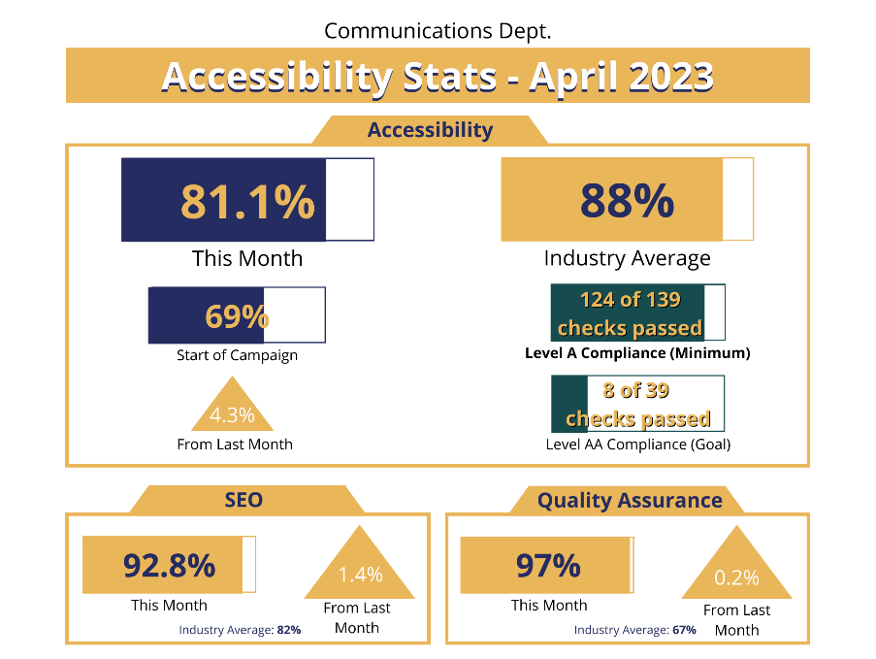
- Town Communication Tools – The Town maintains a diverse set of communications tools, including social media, a newsletter, email communications, and the website. Our Facebook and Instagram followings continue to grow steadily, and the past month has seen significantly higher than average engagement with Town social media and the website. The new Town email lists continue to add subscribers and boast fantastic engagement numbers: according to the Town’s email vendor, Constant Contact, the average open rate for government organizations is just 35.45%.
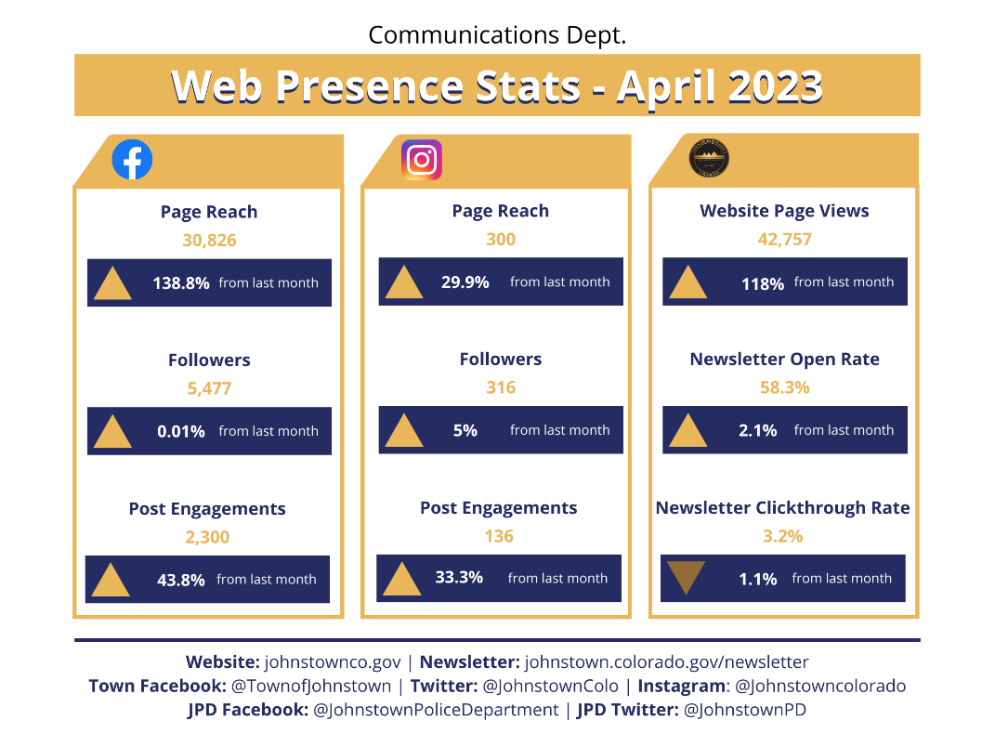
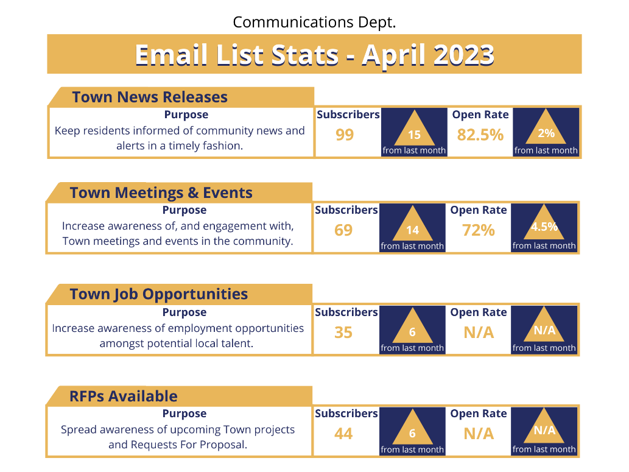
- Community Engagement Events – Town Staff engaged with the community in April at the Town Tree Giveaway on April 13, Clean Up Day on April 22, DEA Drug Takeback on April 22, and upcoming events include the May 6 Cinco De Mayo Event in Downtown Johnstown, the Arbor Day Edu Tour with our local 4th graders, and June 3 BBQ Day event. These events serve as a great opportunity for Town Staff and Town Council to engage with residents, businesses, and visitors. Sharing Town information with residents and meeting the community where they are is a priority for the Town and promotes engagement and transparency.
- Land Use & Development Code – Public Hearing was held April 17, 2023, and Town Staff continues to clean up housekeeping items for a planned publication and roll out in May, assuming final adoption. Updated worksheets and development guides are in process, with a presentation to developers and designers anticipated in late May.
- CDOT – Staff has been actively coordinating with CDOT on a number of projects, including Purvis Farm, Ledge Rock Center, Ridge and Encore, and several prospective developers to ensure the sharing of information and successful facilitation of projects and improvements.
- Planning & Zoning Commission (PZC) – The Commission met on April 12 to review the proposed Land Use & Development Code. The next meeting is expected on May 24. New commission members are still sought with applications, available online, accepted until at least May 15.

Police Department
Training:
- Firearms Training and Qualifications – The entire department participated in state mandated firearms training at the Northern Colorado Training Center. Officers qualified on handgun and rifle and practiced shooting with shields and from behind barriers. Training was instructed by Officer Morgan and Officer Olds
- Narcotics Interdiction Training – Officer Olds attended “Criminal Interdiction Class.” This training is designed to instruct officers to look for indicators of criminal activity during traffic stops.
- Marksmen Training – Officer Morgan attended “Designated Marksman Training.” This course teaches how to reach marksmen level shooting skills.
- Overdose Investigations – Officer Jaramillo completed an Overdose Investigation Course sponsored and instructed by HIDTA. This training provides insight into how to determine what types of things a first responder should look for to make the decision to proceed with an overdose investigation.

Community Policing, Outreach & Miscellaneous Items:
- Polar Plunge – Grace Hamilton, Christy Adair, Detective Grounds, Sergeant Brown, Lieutenant Williams, and Commander Oglesby participated in the Polar Plunge for the Special Olympics. They plunged at Windsor Lake.
- New Officer – Officer Kale Mayfield was sworn in as a Police Officer for the Town of Johnstown. He is currently in our mini academy before starting his FTO program.
- 2022 Financial Audit – Fieldwork for the 2022 Audit began on April 24th. The audit work will be completed remotely.
- 2023 Budget – The 2023 Budget has been completed and is available on the Town’s website.

Public Works
- Crews completed 78 work orders this review period consisting of prep site for spring cleanup, pickup trees for Arbor Day, construction inspections, street sweeping, gravel road grading, filling potholes, road sign repair, installing new woodchips at parks, cemetery cleanup, funerals, and a variety of other streets and grounds related work.
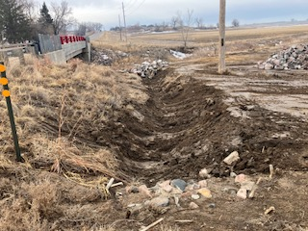
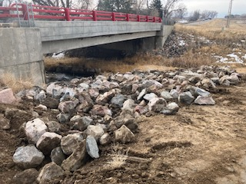

Little Thompson Trail:
- The contractor has encountered some areas of poor subgrade and repairs are in progress.

Charlotte Street Improvements:
- The contractor continues to work with the full width street closure from Estes to Greeley. Sanitary sewer pipe and waterline installation have been completed and testing should be completed the week of April 24. The contractor will be installing the storm sewer line next. The three-week look ahead is located on the Town website.
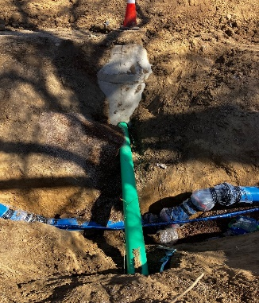
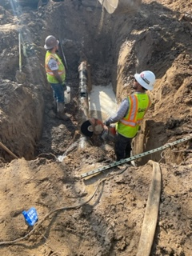

Buc-ee’s:
- Attended Consolidated Home Supply Ditch Company realignment walkthrough. Consolidated Home Supply Company approved all installation.

The Granary PH 1 B
- Proof rolled for curb and gutter and installation.
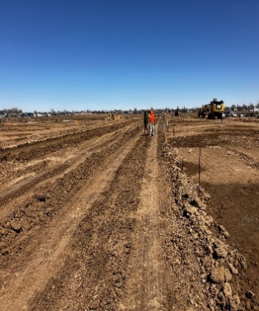
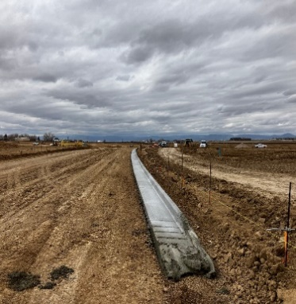
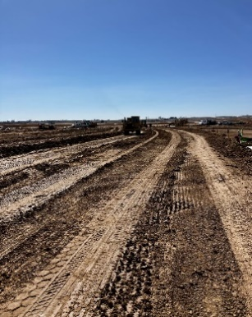

County Road 3
- Proof rolled prior to walkway installation.
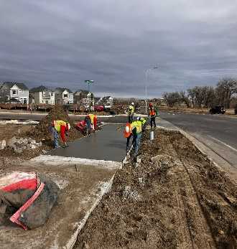
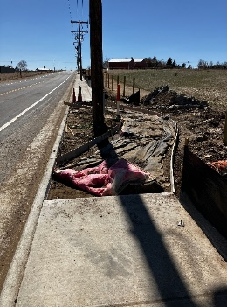
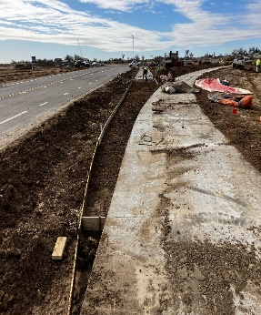

North Ridge
- Inspected and approved storm line baskets and inlet forms.
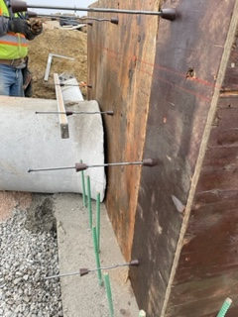
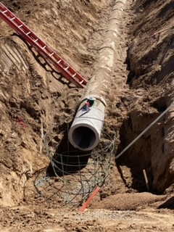
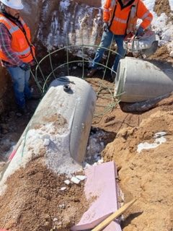

Johnstown Village PH 1 Punch List Inspections
- Approved subgrade compaction after removals. Inspected and approved new installation.
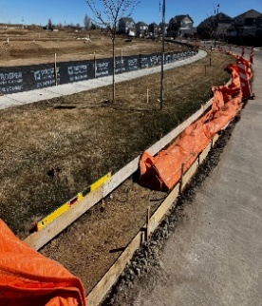
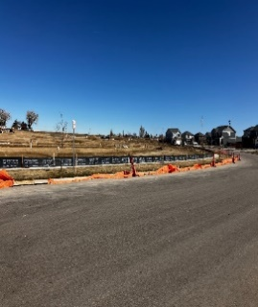

The Ridge Filing 1
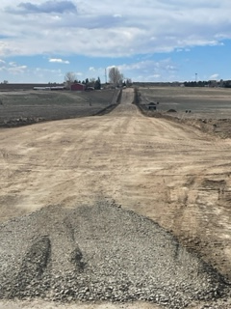
- CR 3E subgrade treatment is completed.

Ledge Rock
- Ledge Rock Ditch Realignment Walk Though was completed and approved by the Consolidated Home Supply Company. The Public Works Department requested the installation of erosion control along all new dirt bank construction, which will be inspected by the Town after the completion.
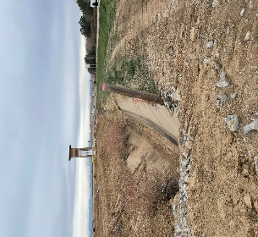
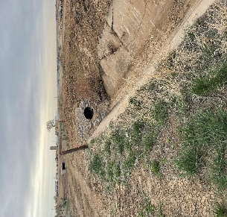

Utilities
- Treatment
  - WTP:
    - Average Daily Flows: 1.423 MGD
    - The Town’s new Water Superintendent ORC, John Ferguson, started in April.
    - Town hired a contractor to replace & repair the air release valves on the GAC vessels due to damage incurred during operations in freezing temperatures. GAC vessels will be filled and leak tested prior to loading carbon for the season.
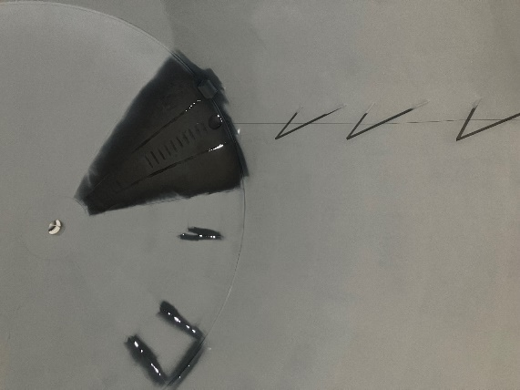
    - The Contractor, Tanco, on the North Ground Storage Tank project has completed the sand blasting of the inside of the north storage tank, constructed the new fill line, and repairing holes. Coating is anticipated to be completed by the end of the month.
    - Operations filled the 2nd treatment basin for the DAF with potable water in preparation for the seasonal increased water demand after its seasonal shutdown for winter flows and maintenance activities.
  - Low Point WWTP:
    - Average Daily Flows: 0.55MGD
    - Operations completed repairs on a gearbox and auger for the Rotary Fan Press that has been down for several weeks. This repair enables Staff to treat solids again onsite and stops the requirement to liquid hauling until repair parts arrived.
    - The integration team had a kickoff meeting on the SCADA system for Low Point to walk through the system and working screens with the Operators.
    - Operators worked together to trouble shoot and fix decanting arm gearbox issues on the south basin of the SBR.
    - Operators rerouted the filtrate from sludge holding tanks to splitter box feeding SBR’s to optimize sludge storage volume and remove unnecessary steps to the treatment process.
  - Central WWTP:
    - Average Daily Flows: 0.96MD
    - The Town purchased and transported four directional mixers from Bennett CO to improve the treatment occurring in the lagoons.
    - Operations hired a contractor to clear a blockage in the influent line from the splitter box to Pond 1. This clearing allowed for operations to shut the influent line to Pond 2 and route treatment through Pond 1 to increase contact and treatment time.
    - Operations scheduled repairs and maintenance on regen blowers for lagoon aeration on the east side Pond 1.
- Sewer Collection & Water Distribution
  - Locates: 681 tickets
  - Meters: 22 new installs, 4 Replacements
  - DES came in and cleaned standing trash and grease from lift stations and is wrapping up video inspections in the 2534 area and Downtown area.
  - A fire hydrant in front of Atlas Storage was struck by a vehicle so the crew had to reinstall new extension and traffic breakaway kit.
  - Indigo Water held a two-day training event for water and wastewater operations.
- Inspections
  - 19,332’ water main installed and tested
  - 3,523 sewer main installed and tested
  - 19 manholes installed and tested
  - 30 water/sewer inspections
- GIS
  - Added 4.1 miles of water pipes into the GIS database.
  - Added 8.0 miles of wastewater pipes into the GIS database.
  - Started a data exchange process with the City of Loveland for fire hydrant info served by the Loveland Fire and Rescue Authority.
  - Utility data collection is nearing completion in the 2534 area per attached map.
- Capital Projects
  - Raw Water Transmission–The design engineer is continuing to work with Town Staff to set the final alignment from Lone Tree to the Water Treatment Plant. The Town is also working with the Home Supply Ditch Company on the location of the new pump station at Lone Tree Reservoir. In addition, meetings are being held with neighboring jurisdictions to determine their review and permitting processes.
  - South Water Tank– The tank contractor is continuing to work on the interior piping, electrical, and civil site work as weather permits. The contractor is estimating to be completed with the tank in May, weather dependent.
  - South Water Tank Distribution Pipeline – The contractor is working on completing the last stretch of mainline down WCR42 in May. The contractor was delayed due to the weather towards the end of March, but we will continue to work together as the project is nearing completion. Testing of the water main began in April.
  - Water Treatment Plant Expansion – Town Staff, the design engineer, the owner’s representative, and the construction manager are working on value engineering as the design continues to progress to 60%. The construction manager has developed an overall project schedule and preliminary cost estimate based on the revised 30% plans. Town staff is actively working with all representatives on the preliminary schedule and cost estimate.
  - North Interceptor – The contractor has begun pouring the north half of the wet well walls for the lift station and anticipates completing the walls in April. The Hillsborough Ditch and railroad/County Road 17 bores have been completed. The contractor has also completed the installation of mainline from the Central Wastewater Treatment Plant to the north and west that was planned prior to the start of irrigation season. Mainline installation will start back up in September.
  - Low Point Sewer Expansion – The contractor continues installing equipment in the Membrane Bioreactor (MBR) and Headworks building as it arrives on site. Town Staff and the Contractor are working together to schedule trainings for staff on the new equipment and testing. In addition, Staff is working with the programmer to review the proposed interface to control the plant.
  - Central Plant Design – A pre-construction meeting was held in April and site grading is underway. Staff will continue to work with the contractor and design engineer throughout construction on permitting and construction progress.
  - State Highway 60 Waterline– Over the next six months Town Staff will work with the design engineer on final alignment and obtaining all necessary easements and agreements. Town Staff continues to work on alignment options with the Design Engineer.

